**Final Report**

:: Which factors affect to house energy efficiency? ::

|  |
| --- |
| **Abstract**  To investigate which factor is important for pleasant and comfortable house, we focused on Thermal load(Heating load and Cooling load) in terms of energy efficiency. In this study, we performed Variables Identification, Correlation Analysis, Multiple Regression Analysis.  As a result, we could know ‘Wall Area’, ‘Overall Height’, ‘Glazing Area’ have negative affect on energy efficiency and ‘Surface Area’ has positive effect. The result about ‘Relative Compactness’ is not correspond with each analysis. By the hand, ‘Orientation’ and ‘Glazing area distribution’ seems not related with energy efficiency.  The influence of variables are larger Relative Compactness, Glazing Area, Overall Height, Surface Area, Wall Area in series.  Although, study has distinct limitations, this result can be direction for house selection in terms of energy efficiency. |

|  |
| --- |
| **Contents**  **1. Introduction**  1. 1 Background of Project and Research Question  1. 2 Thermal load : Heating load & Cooling load  1. 3 Preceding Research  **2. Data Analysis**  2. 1 Analysis Approach and Variables Identification  2. 2 Statistical Description of Dataset  2. 3 Correlation Analysis  2. 4 Multiple Regression Analysis  **3. Conclusions and Future Directions**  **4. References** |

OBYG : DongHyuk_Kim/ SeungHwan_Kim/ YuJeong_Lee/ Hyerin_Kim

**1. Introduction**

**1. 1. Background of Project and Research Question**

We say that food, clothing, shelter are 3 necessities of living, and there is no doubt that residential environment is closely connected with quality of life. That is why not even college students, but also people who just got out of college, newlyweds, and couples who prepare for their old age put much effort choosing rather suitable, pleasant and comfortable house. If there is no limit in budget and time, we don't have to struggle choosing it, but unfortunately most of us are constraints and we should deal with a matter of choice.

**1. 2. Thermal load : Heating load & Cooling load**

Then, what it means that pleasant and comfortable house for people? How can we estimate the satisfied qualitative variables for statistical analysis? For the first time, we would represent 'Heating load' and 'Cooling load' for objectification of satisfactory and comfortable in this group project. The Heating load is defined as "The amount of heat energy that would need to be added to a space to maintain the temperature in an acceptable range" and the cooling load is "The amount of heat

energy that would need to be removed from a space (cooling) to maintain the temperature in an acceptable range". The heating and cooling loads collectively called "Thermal loads".

**1.3. Preceding Research**

Though, there is a research of FC McQuiston, JD Parker as much cited research, that is old research and there has been many change of materials and development of construction techniques for 30 years, we need to set effect of novel variables. Besides, there are researches of effect analysis on the Thermal Load by balcony of apartment house(YongTaek Park, 2000), analysis and design of heating, ventilating, and air conditioning(FC McQuiston. et al. 1982), and cooling load prediction for buildings using general regression neural networks(Elsevier, 2004).

Most existing researches analyzed the influence of specific variable. In addition to that, this report includes process exploring variables which significantly affect Thermal Load and process comparing the influences between each variable, though there are researchers' technical limitations as undergraduate students.

The goal of this 3-weeks project is to find out which factor is the most influential to heating and cooling load. Through this group project, we expect we will be able to adapt the result when choosing our own residence in real life.

**2. Data Analysis**

**2. 1. Analysis Approach and Variables Identification**

There can be many factors which can affect Thermal load. In this study, we focused on following building characteristics about walls, floors, roofs and windows.

As independent variables we used 8 characteristics. Relative Compactness(X1) , Surface Area(X2, m²), Wall Area(X3, m²) , Roof Area(X4, m²), Overall Height(X5, m), Orientation(X6), Glazing Area(X7, %), Glazing area distribution(X8). Relative Compactness of the building(X1) means ratio of volume over exterior envelope area relative to ratio of the volume over exterior envelope area for a reference building. Orientation(X6) has 5 types, uniform, oriented house with 25% glazing on each side coded value 1, North oriented house, means 55% on the north side and 15% on each of the other sides coded as 2, East as 3, South as 4 and West as 5. Glazing area distribution(X8) coded same way as X6. Glazing Area(X7) expressed as the percentages of glazing areas.

And we used 2 dependent variables, Heating load(Y1, kWh/m²) and Cooling load(Y2, kWh/m²)

**2. 2. Statistical Description of Dataset**

The number of objects is 768 each variable, and descriptive statistics of data set is below, Table 1. And probability histogram of core features is following, Figure 1.

Table 1. Descriptive statistics of dataset

|  |  |  |  |  |  |  |
| --- | --- | --- | --- | --- | --- | --- |
|  | X1 | X2 | X3 | X4 | Y1 | Y2 |
| median | 0.75 | 673.75 | 318.5 | 183.75 | 18.95 | 22.08 |
| max | 0.98 | 808.5 | 416.5 | 220.5 | 43.1 | 48.03 |
| min | 0.62 | 514.5 | 245 | 110.25 | 6.01 | 10.9 |
| mean | 0.764167 | 671.7083 | 318.5 | 176.6042 | 22.3072 | 24.58776 |
| sd | 0.105777 | 88.08612 | 43.62648 | 45.16595 | 10.0902 | 9.513306 |

Figure 1. The distribution of the core feature

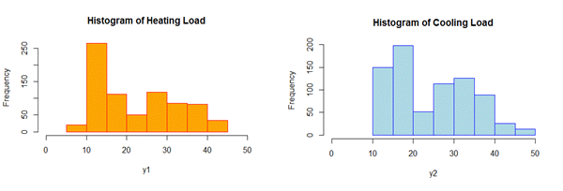

**2. 3. Correlation Analysis**

Figure 2. Boxplot

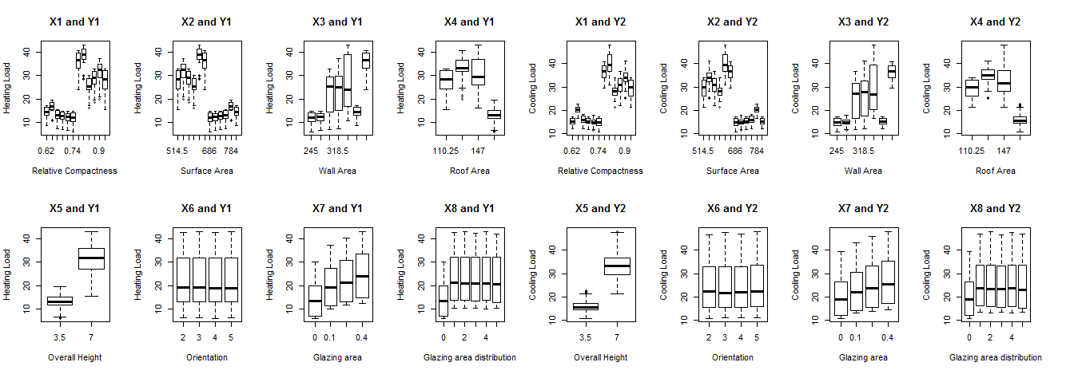

Table 2. Calculated Correlation Coefficient

|  |  |  |  |  |  |  |  |  |
| --- | --- | --- | --- | --- | --- | --- | --- | --- |
|  | X1 | X2 | X3 | X4 | X5 | X6 | X7 | X8 |
| Y1 | 0.622 | -0.658 | 0.455 | -0.861 | 0.895 | -0.002 | 0.269 | 0.087 |
| Y2 | 0.634 | -0.672 | 0.427 | -0.862 | 0.895 | 0.014 | 0.207 | 0.050 |

As a result of correlation analysis shows X1, X3, X5, X7 is positive correlated with Y1 and Y2, means they can have negative effect on energy efficiency. Otherwise, X2 and X4 is correlated negative with Y1 and Y2, means they have positive effect on energy efficiency of house. However, X6 and X8 is seems not correlated with Thermal load.

**2. 4. Multiple Regression Analysis**

Considering result of Correlation analysis, we exclude variable Orientation(X6) and Glazing area distribution(X8) with low correlation. And multicollinearity between Roof Area(X4) and other variables, we also excluded X4 from Multi Regression model. We used two models below, Model1 and Model2.

**Model 1. $Y_{1}=Intercept+α_{1}X_{1}+α_{2}X_{2}+α_{3}X_{3}+α_{5}X_{5}+α_{7}X_{7}$**

**Model 2. $Y_{2}=Intercept+β_{1}X_{1}+β_{2}X_{2}+β_{3}X_{3}+β_{5}X_{5}+β_{7}X_{7}$**

And the estimation result is below, Table1, and Table2.

Table 3. Estimation Result of Model 1

|  |  |  |  |  |  |
| --- | --- | --- | --- | --- | --- |
|  | **Estimated** | **Std** | **t-Value** | **Pr(>|t|)** |  |
| **Intercept** | 84.38757 | 19.11175 | 4.415 | 1.15E-05 | *** |
| **X1** | -64.774 | 10.33361 | -6.268 | 6.11E-10 | *** |
| **X2** | -0.08729 | 0.017149 | -5.09 | 4.51E-07 | *** |
| **X3** | 0.060813 | 0.006676 | 9.109 | < 2e-16 | *** |
| **X5** | 4.169939 | 0.339441 | 12.285 | < 2e-16 | *** |
| **X7** | 20.4379 | 0.798726 | 25.588 | < 2e-16 | *** |
| Multiple R-squared : 0.9153, Adjusted R-squared : 0.9147, F-statistic: 1646 on 5 and 762 DF, p-value: < 2.2e-16 | | | | | |

Table 4. Estimation Result of Model 2

|  |  |  |  |  |  |
| --- | --- | --- | --- | --- | --- |
|  | **Estimated** | **Std** | **t-Value** | **Pr(>|t|)** |  |
| **Intercept** | 97.76185 | 20.75634 | 4.71 | 2.94E-06 | *** |
| **X1** | -70.7877 | 11.22282 | -6.307 | 4.80E-10 | *** |
| **X2** | -0.08825 | 0.018624 | -4.738 | 2.57E-06 | *** |
| **X3** | 0.044682 | 0.007251 | 6.162 | 1.16E-09 | *** |
| **X5** | 4.283843 | 0.36865 | 11.62 | < 2e-16 | *** |
| **X7** | 14.81797 | 0.867458 | 17.082 | < 2e-16 | *** |
| Multiple R-squared : 0.8876, Adjusted R-squared : 0.8868, F-statistic : 1203 on 5 and 762 DF, p-value : < 2.2e-16 | | | | | |

As a result of multi-regression analysis shows X3, X5, X7 grows Thermal load(means negative effect on energy efficiency). X1, X2 low Thermal load(means positive effect on energy efficiency of house). The effect of variables are bigger in series X1, X7, X5, X2, X3.

**3. Conclusions and Future Directions**

Through this study, we could know Wall Area(X3), Overall Height(X5), Glazing Area(X7) have negative affect on energy efficiency and Surface Area(X2) has positive effect. The result of two meth

d on Relative Compactness(X1) is not correspond with. Orientation(X6) and Glazing area distribution(X8) seems not related with energy efficiency.

When faces house selection, its more important factor in series Relative Compactness(X1), Glazing Area(X7) , Overall Height(X5), Surface Area(X2), Wall Area(X3) in terms of energy efficiency.

Our study have limitations of statistical skills and the try to answer the question “What factor is more important for pleasant and comfortable house?” just in terms of energy efficiency. But we can learn get directions at least in terms of energy efficiency.

**4. References**

1) The Building Sustainability Index (BASIX), New Sounth Wales Goverment, http://www.basix.nsw.gov.au

2) Effect Analysis on the Thermal Load by Balcony of Apartment House(2000), Yong-seung Park, Eun-taek Lee, Hee-ghi Hong

3) Heating, ventilating, and air conditioning: analysis and design(1982), FC McQuiston, JD Parker. osti.gov

4) Cooling load prediction for buildings using general regression neural networks, AE Ben-Nakhi(2004), MA Mahmoud

5) Energy Conversion and Management(2004), Elsevier

6) Accurate quantitative estimation of energy performance of residential buildings using statistical machine learning tools(2012), Athanasios Tsanas, Angeliki Xifara

7) Impact of building shape on thermal performance of office buildings in Kuwait(2009), Adnan AlAnzi, et al.

8) Impact of shape on building energy use in Tunisia(2006), Kais Ouertani